HIGH LEVEL DESIGN FOR MATRIX

DOCUMENTS CONTROL
Document Description
Document Title : Matrix architecture and design document
Document Version : 1.0
Author : Sangeeth.25@wipro.com

Version Control
S No | Version No | Date | Reviewed By | Approved By
1 | 1.0 | 25/03/2025 | Vino Jose | Ragavendra Hosabettu

Table of Contents
INTRODUCTION 4
Solution Overview 4
Document Scope 4
Definitions, Acronyms and Abbreviations 4
MATRIX SOLUTION OVERVIEW 5
Matrix Solution Architecture 5
Architecture vision and goal 6
Vision 6
Goals 6
MATRIX COMPONENT DESIGN 7
Component Description 7
Data Sources 7
Matrix AI Agents / logical components 7
Data Store 8
AI Service 8
Data Design 8
Open-source tools 8
MATRIX SECURITY CONSIDERATION 9
Privacy considerations 9
Data handling 9
TESTING AND VALIDATION 10
Testing strategy 10
Test cases and scenarios 11
Validation criteria 11
DEPLOYMENT AND MAINTENANCE 12
Deployment Pre-Requisite 12
Deployment Architecture 14

INTRODUCTION

Solution Overview
This document explains high level view of the product architecture and design of Matrix (Multi-agent Al driven Troubleshooter and Root cause Identification Xpert), a Generative AI application used as a proactive alert, event monitoring, and remediation tool, particularly for IT Operations (ITOps).
Matrix integrates with ITSM and event management tools to gather data from various sources like monitoring tools, CMDB, and live data from devices. It uses a GenAI multi-agent framework for data analysis, including agents like the Planner, Data Collector, and Root Cause Finder. The system is designed to handle incidents efficiently by automating the data collection, analysis, and help in generating resolution steps.

Document Scope
The document scope includes details of Matrix Generative AI application for
- Solution Architecture
- Matrix Use Case
- Matrix Solution characteristics
- Matrix Deployment
- Matrix Data
- Solution Security
- Matrix solution Configuration & Customization

Definitions, Acronyms and Abbreviations
- Matrix: Multi-agent AI driven Troubleshooter and Root cause Identification Xpert.
- ITOps: IT Operations.
- OEM: Original Equipment Manufacturer.
- AI: Artificial Intelligence.
- LLM: Large Language Model.
- ITSM: IT Service Management.
- CMDB: Configuration Management Database.
- DB: Database.

MATRIX SOLUTION OVERVIEW

Matrix Solution Architecture

The architecture is implemented taking into consideration design based on modularity, easy customization & integration. The architecture of the product helps in organizing the codebase, making it more maintainable and scalable.
The architecture comprises of the following components, with the workflow in the given order
- Source Data
- Matrix Product - Analysis & Remediation
- ITSM Integration
- AI Services
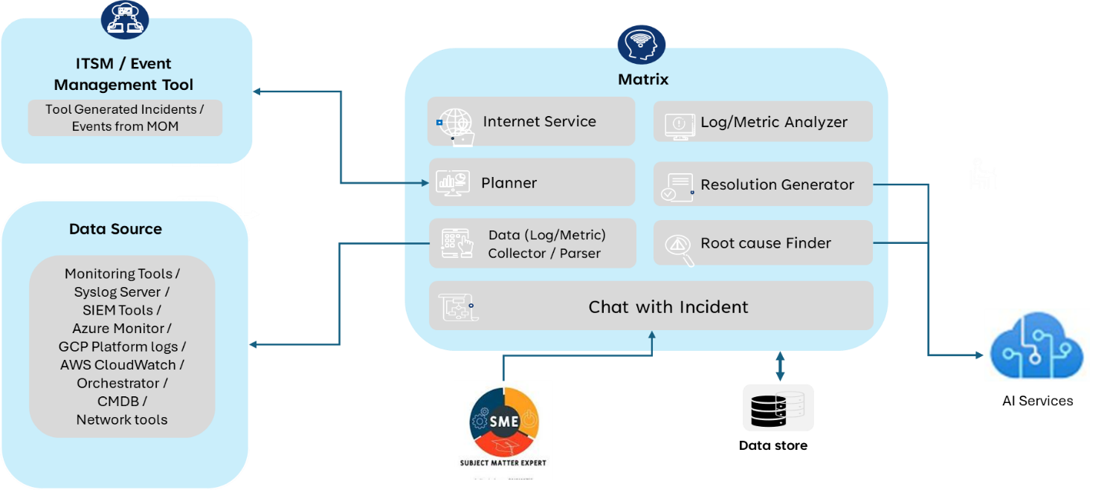

Architecture vision and goal

Vision
The architecture vision for Matrix (Multi-agent AI driven Troubleshooter and Root cause Identification Xpert) is to create a robust, scalable, and efficient Generative AI application that serves as a proactive alert, event monitoring, and remediation tool for IT Operations (ITOps). The system is designed to integrate seamlessly with existing ITSM and event management tools, leveraging a multi-agent framework to automate the data collection, analysis, and resolution processes. The architecture aims to provide a comprehensive solution that replicates the actions of a Subject Matter Expert (SME) in handling incidents, ensuring quick and accurate identification of root causes and suggesting effective resolution steps.

Goals
- Proactive Monitoring: Matrix provides continuously monitors critical devices and systems, identifying potential issues before they escalate into major incidents.
- Automated Data Collection: Develop agents that can automatically gather relevant data from various sources, including monitoring tools, CMDB, and live data from devices.
- Efficient Root Cause Analysis: Utilize AI-driven agents to analyze collected data, identify the root cause of issues, and correlate events across different systems.
- Effective Resolution Suggestions: Generate accurate and actionable resolution steps based on the analysis, leveraging historical data and SME knowledge.
- Integration: Matrix Provide seamless integration with existing ITSM and event management tools to enhance the overall RCA process.
- Continuous Improvement: Establish a feedback loop with SMEs to continuously improve the system's accuracy and effectiveness based on real-world incidents and user feedback.

MATRIX COMPONENT DESIGN

Component Description

Data Sources
The data sources for Matrix include:
- Monitoring tools
- Syslog servers
- Azure monitoring
- Configuration Management Databases (CMDB)
- Live data from devices
These sources provide comprehensive log data, event information, and topology details essential for effective monitoring and troubleshooting.

Matrix AI Agents / logical components
Matrix is composed of a custom agentic framework with multiple agents, each designed to perform specific tasks:

Planner
Analyses alert data and determines additional relevant data required.

Data Collector/Parser
Collects relevant information from various data sources.

Finder
Identifies other components contributing to the issue.

Log/Metric Analyzer
Correlates data to identify the root cause of the issue.

Resolution Generator
Gathers data from previous agents and identifies resolution steps.

OEM KB Integration
Optional integration for accessing specialized knowledge from the Original Equipment Manufacturer (OEM)

Data Store
A data lake is a centralized repository that allows you to store all your structured and unstructured data at any scale.

AI Service
AI service will be used to inference LLM from various llm provider based on customer choice

Data Design
The data design involves collecting data from various sources and storing it in a centralized repository known as a data store. The data store stores both processed and unprocessed, which is then retrieved and processed for root cause analysis. The system integrates with ITSM and event management tools to collect comprehensive incident and event information.

Open-source tools
Elasticsearch
Elasticsearch is used as data lake, it will store all the data temporarily which are used for analysis.
Kibana
Used to view the data that are collected in data lake.
Postgres DB
Used to store incident and ither details on which Matrix worked on.
Python
Matrix solution run using python, below are the few packages and frameworks required
- tensorflow
- dspy-ai
- elasticsearch
- google
- bs4
- loguru
- psycopg2-binary
- Markdown
- Django
- PyYAML
- Paramiko
- tiktoken

MATRIX SECURITY CONSIDERATION

Privacy considerations
The Matrix solution is designed with a strong emphasis on privacy and data protection. The following privacy considerations have been implemented to ensure the security and confidentiality of data:
Data Segregation:
Data collected from various sources, such as monitoring tools, syslog servers, Azure monitoring, and Configuration Management Databases (CMDB), will be segregated and stored in a centralized repository known as a data lake. This data lake will be hosted on-premises to maintain data integrity and security.
No Data for Training:
The data collected and processed by the Matrix project will not be used for training purposes. This ensures that sensitive information is not exposed or used inappropriately. The AI agents will leverage pre-trained models and will not require additional training data from the collected information.

Data handling
Securing data at Rest
The data store is hosted on customer premises to maintain data integrity and security.
Access Control: Implement strict access control policies to restrict access to the data store and databases. Only authorized personnel will have access to the data, and access should be granted based on the principle of least privilege.
Securing Data while Processing
Data Anonymization: Implement data anonymization to protect sensitive information during processing. This ensures that sensitive data is not exposed to unauthorized personnel
Audit Logs: Maintain audit logs of all data processing activities. This helps in tracking anonymization process and performance.

Securing Data while transmitting
Secure Transmission: Uses secure transmission protocols such as SSH and HTTPS to protect data during transit. This ensures that data is encrypted and protected from interception by unauthorized parties.
Regular Audits: Conduct regular audits to ensure that data handling practices comply with security policies and standards

TESTING AND VALIDATION

Testing strategy
The testing strategy for the Matrix project involves a comprehensive approach to ensure the system's functionality, performance, and reliability. The strategy includes the following key components:
Unit Testing:
Each component of the Matrix system will undergo unit testing to verify that individual parts function correctly. This includes testing the AI agents, data collectors, and other modules.
Integration Testing:
Integration testing will be conducted to ensure that all components work together seamlessly. This involves testing the interactions between different modules and verifying data flow and communication.
System Testing:
System testing will be performed to validate the overall functionality of the Matrix system. This includes testing the system's ability to handle real-world scenarios and ensuring it meets the specified requirements.
Performance Testing:
Performance testing will be conducted to evaluate the system's performance under various conditions. This includes testing the system's response time, scalability, and ability to handle high volumes of data.

Test cases and scenarios
To validate the effectiveness of the Matrix system, we will collect the top call drivers (incidents) from the past three months. These incidents will be analysed to develop test cases and scenarios that reflect real-world situations. The test cases will include:
- Incident Identification: Verify that the system can accurately identify and categorize incidents based on the collected data.
- Root Cause Analysis: Test the system's ability to perform root cause analysis and identify the underlying causes of incidents.
- Resolution Generation: Validate the system's capability to generate effective resolution steps for identified incidents.
- Data Collection and Parsing: Ensure that the data collector and parser agents can accurately collect and parse relevant information from various sources.
- Agent Collaboration: Test the collaboration between different AI agents to ensure they work together to resolve incidents efficiently.

Validation criteria
To ensure the accuracy and effectiveness of the Matrix system, the output will be validated with Subject Matter Experts (SMEs). The validation process will include:
- Review of Test Results: SMEs will review the test results and provide feedback on the system's accuracy.
- Validation of Resolution Steps: SMEs will validate the generated resolution steps to ensure they are effective and appropriate for the identified incidents.
- Continuous Improvement: Based on the feedback from SMEs, the system will be continuously improved to enhance its accuracy and effectiveness.
By implementing this comprehensive testing and validation strategy, the Matrix project aims to ensure a high level of functionality, performance, and reliability.

DEPLOYMENT AND MAINTENANCE

Deployment Pre-Requisite
Below are the pre-requisites for deploying matrix.
S No | Deployment Pre-Requisite | Required By | Remarks
1 | Connector / way to transfer binary to account | Start of the project
2 | Selection of LLM based on Enterprise requirements & choices. | Start of the project
3 | SMEs from Network tower to provide data like logs and other relevant data required for analysis as per discussion. | Start of the project
4 | CMDB/Network topology details to be provided | Start of the project
5 | SOP's, KB articles, OEM Knowledge articles (Optional for better RCA) | During the first week of the project start date
6 | 1 VM(RHEL latest OS, 16 core CPU, 64 GB RAM, 1 TB Storage) | Start of the project | Storage requirements are calculated based on the generation of 100 documents per minute per device, with a data retention period of 2 weeks, and a total of 500 devices.
7 | Internet access or whitelisting of the URLs shared for downloading (ElasticDB, Postgres, Python framework, Embedding models and others) | Start of the project | https://docker.elastic.co/v2/  https://registry-1.docker.io/v2/  *pypi.python.org  *pypi.org  *pythonhosted.org  https://huggingface.co/sentence-transformers/all-MiniLM-L6-v2  https://auth.docker.io/  https://index.docker.io/  https://*.cloudfront.net  https://*.docker.com  https://hub.docker.com/_/postgres  https://docker.elastic.co/
8 | Relevant ports to be opened for data access/UI (Details to be discussed) | Start of the project
9 | Team onboarding and getting access to environment. | Start of the project
10 | Exposing data APls for consuming incident, service data from ITSM tool | Start of the project
11 | Service Accounts with credentials to integrate to read the data from different subsystems and read-only to management servers (e.g. ServiceNow - user access to update incident work notes) | Start of the project
12 | Customer to share the data required for the POC in privacy compliant format (eg: PII and other critical data masked) | Start of the project
13 | Docker License requirement for running containers | Start of the project

Deployment Architecture
The deployment architecture for the Matrix project is designed to ensure a seamless and efficient deployment process. It involves several key components and steps to ensure the system is set up correctly and functions optimally.

